CONFIRMATION OF SENIOR LEADERSHIP ACCOUNTABILITY
Gloucestershire Play Therapy
- Statement of Accountability
This document confirms that Gloucestershire Play Therapy is a sole trader practice, and that the registered practitioner holds full and final responsibility for safeguarding, clinical governance, and professional conduct across all aspects of the service.
The practitioner acts as the designated senior safeguarding lead and is accountable for all safeguarding decisions and actions taken within the service.
- Named Responsible Person
The individual responsible for senior leadership safeguarding accountability is:
Name: Erica Fellows
Role: Sole Practitioner / Owner / Play Therapist
Service: Gloucestershire Play Therapy
- Scope of Responsibility
Senior leadership accountability includes responsibility for:
• Safeguarding children, young people, and vulnerable adults.
• Responding appropriately to safeguarding concerns and disclosures.
• Making referrals to statutory agencies where required.
• Ensuring compliance with safeguarding legislation and local procedures.
• Maintaining professional standards, policies, and procedures.
• Ensuring safe practice across all settings, including schools and private practice.
- Delegation and External Safeguarding Partners
As a sole practitioner, certain safeguarding responsibilities are supported through external agencies, including:
• School Designated Safeguarding Leads (DSLs) when working in educational settings.
• Local Authority Children’s Social Care and Adult Safeguarding Teams.
• Police, where necessary.
• Professional supervisors and relevant professional bodies where applicable.
Ultimate responsibility for decision-making within my practice remains with me as the practitioner.
- Governance and Professional Oversight
I maintain accountability through:
• Regular clinical supervision.
• Ongoing safeguarding training and professional development.
• Compliance with relevant safeguarding legislation and guidance.
• Professional indemnity insurance and ethical practice standards.
- Declaration
I confirm that I hold senior leadership responsibility for safeguarding within Gloucestershire Play Therapy and that I am accountable for ensuring safe, ethical, and legally compliant practice at all times.
Signed: _________________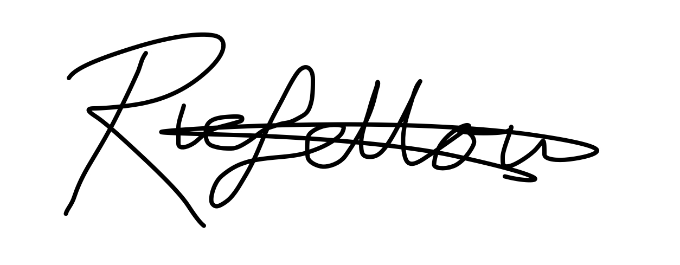______
Name: ____Erica Fellows____________________
Date: __7/6/26______________________
- Review
This statement will be reviewed annually or sooner if required due to changes in legislation or professional guidance.
Last reviewed: 07/06/2026
Next review: 07/06/2027

